**C64 Joystick – Simple Interconnect Board Rev. 0**

**Module description**

# Introduction

This board serves as an interconnect module for the joystick. It provides separability of the arcade joystick, the fire buttons and the joystick cable and reduces the complexity of the wiring and the likelihood of failure.

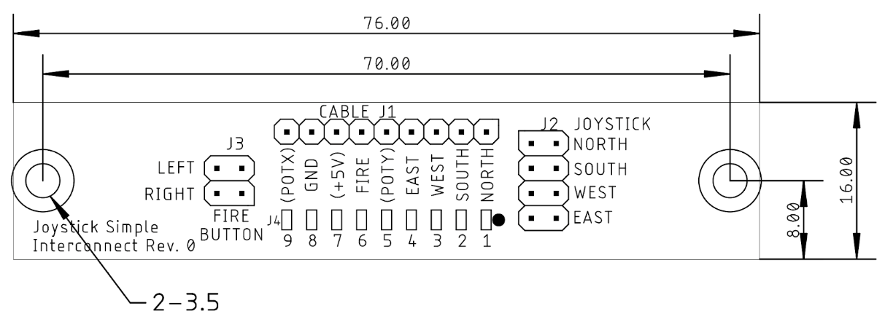

Figure 1: Measures of the PCB

# Connector Pinouts

## Cable connector – J1, J4

J1: Standard pin header, 9pin, 2.54mm pitch (optional)

J4: direct solder pads (surface)

|  |  |  |  |
| --- | --- | --- | --- |
| **Pin J1** | **Pin J4** | **Pin D-Sub (f)** | **Signal** |
| 1 | 1 | 1 | North |
| 2 | 2 | 2 | South |
| 3 | 3 | 3 | West |
| 4 | 4 | 4 | East |
| 5 | 5 | 5 | PotY* |
| 6 | 6 | 6 | Fire |
| 7 | 7 | 7 | +5V* |
| 8 | 8 | 8 | GND |
| 9 | 9 | 9 | PotX* |

## Arcade joystick connector – J2

Standard pin header, 2x4 pins, 2.54mm pitch, matching connector: 2x4 DuPont crimp housing

|  |  |  |  |
| --- | --- | --- | --- |
| Signal | Pin | Pin | Signal |
| North | 1 | 2 | GND |
| South | 3 | 4 | GND |
| West | 5 | 6 | GND |
| East | 7 | 8 | GND |

## Fire Buttons – J3

Standard pin header, 2x2 pins, 2.54mm pitch, matching connector: 2x2 DuPont crimp housing

|  |  |  |  |
| --- | --- | --- | --- |
| Signal | Pin | Pin | Signal |
| Right button | 1 | 2 | GND |
| Left button | 3 | 4 | GND |

## Connecting the Board

The cable with the D-SUB can either be connected to J1 or J4, whatever is easier. The pads of J4 are connected to vias (that means, they have a drill which is plated through). This is to provide more stability to the pads, which would be easy to tear off without those via.

The arcade joystick is connected to J2 and it does not matter, which side of the micro switch is connected to GND or the direction signals (North, South etc.). They do not have a dedicated direction.

The same applies to the fire buttons. It also does not matter, which button is connected to “Left” and “Right”, because both buttons are parallel, the connect to the single Fire signal of the Joystick.